Lab manual – S3 – Replication

Objective.

TO replicate Data from Source AWS Account, **Bucket-01** to Destination AWS Account **Bucket-02**

**Steps:**

1. Create bucket in the Source AWS Account
2. Create bucket in the Destination AWS Account
3. Create the Replication policy
4. Upload the file in the Source Bucket
5. Observe the output
6. Create bucket in the Source AWS Account

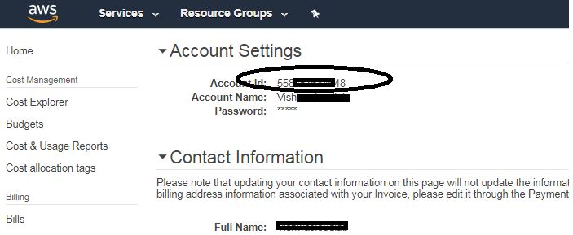

This is Source AWS Account

Now create an bucket. The bucket is created in “**N.Virginia”**

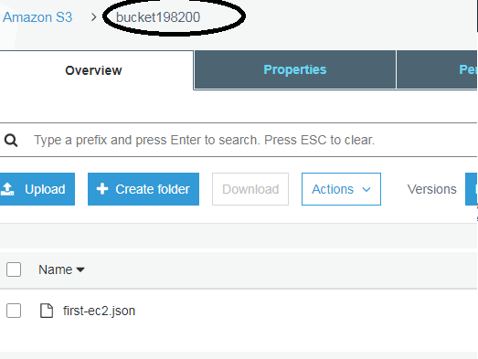

Make sure the “**Versioning**” is enabled.

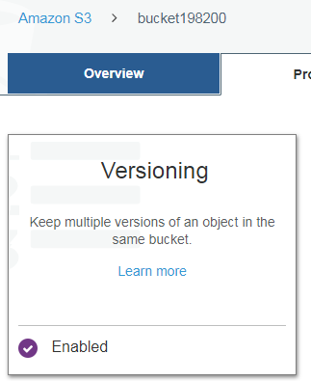



1. Create bucket in the Destination AWS Account

Note:-- Create the bucket in a different Region (Oregon)

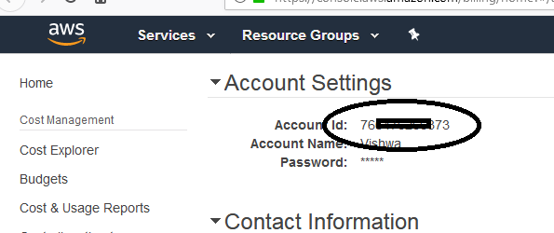

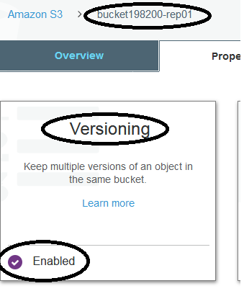



1. Create the Replication policy on the Source Bucket

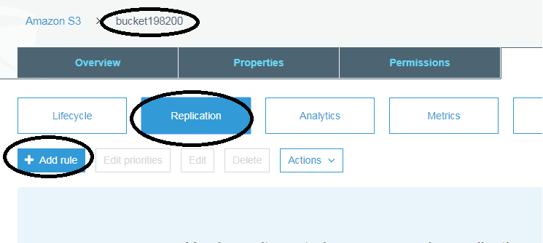

Click on **“Add Rule”**

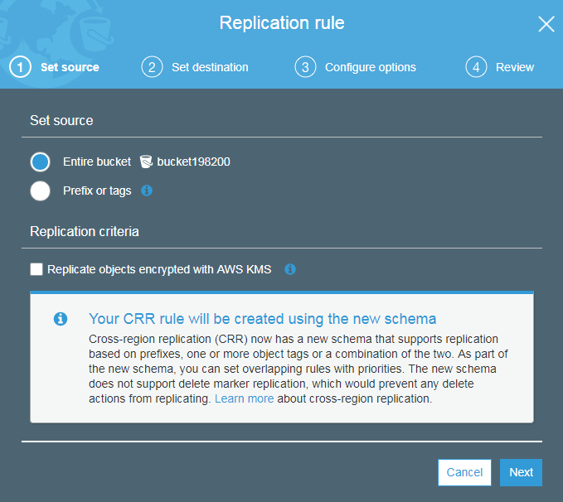

Click **“NEXT”**

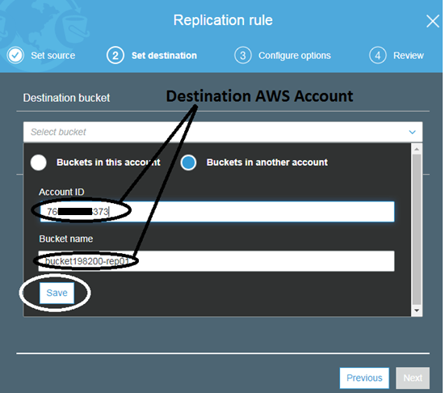

Click on **“Save”**

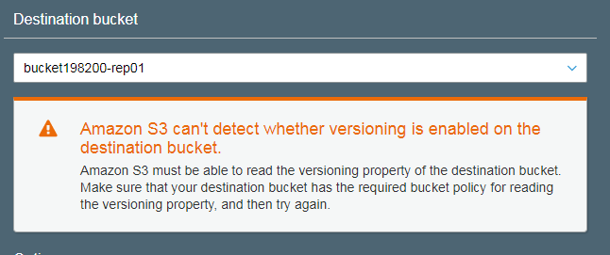

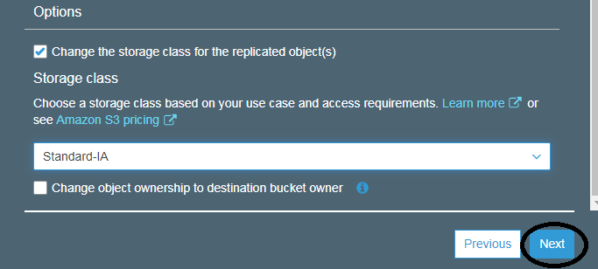

We are NOT giving the ownership of the files to the Destination Bucket.

Click on **“NEXT”**

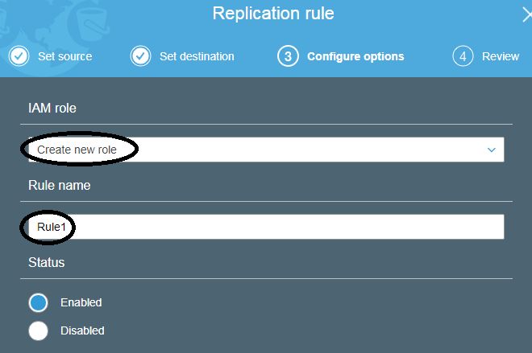

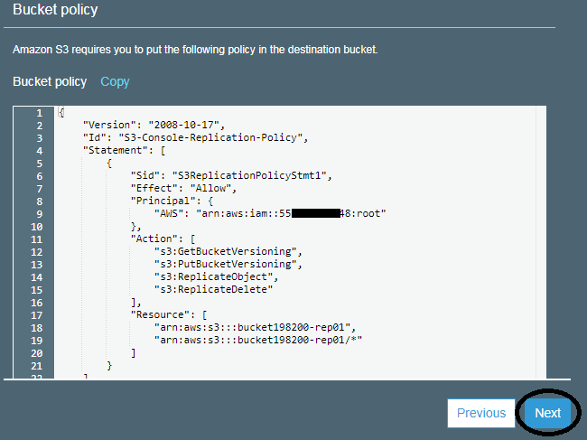

Click on **“NEXT”**

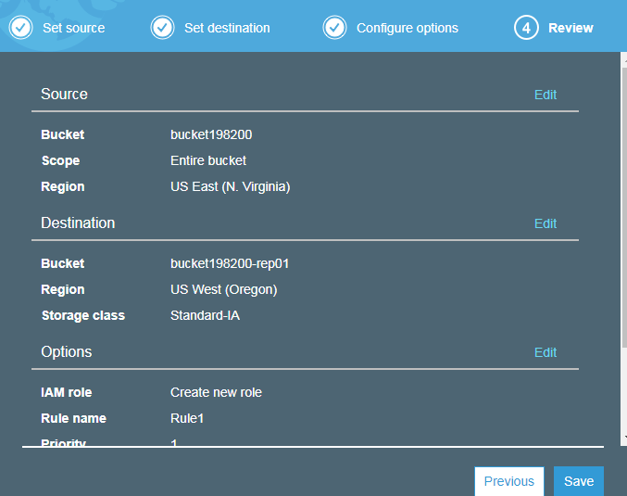

Click on “**SAVE”**

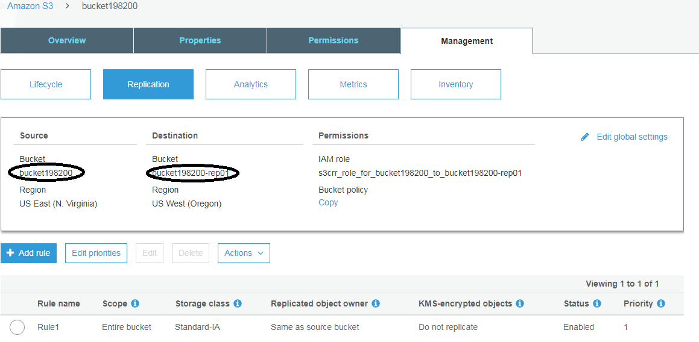

Now that the Replication rule is created.

Now let’s upload a file and chk if the file is getting replicated.

1. Configure the “**Receive object**” in Replication on the Destination Bucket

**Note:-- This step is required only if you are doing the replication between 2 different aws accounts.**

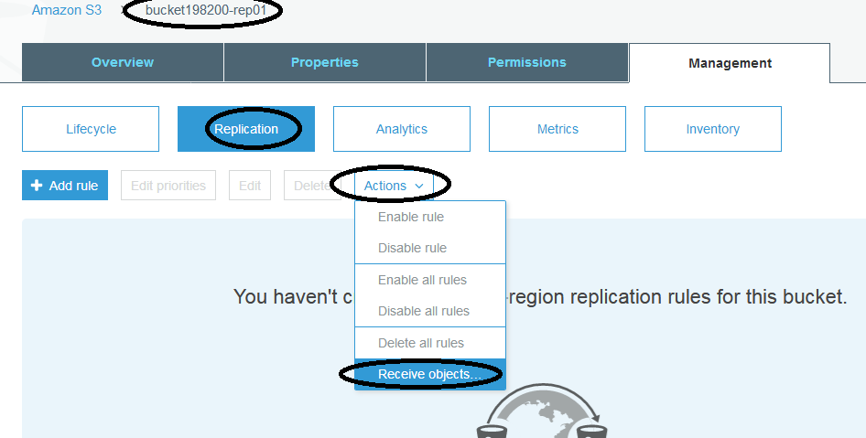

Click on “**Receive Objects”**

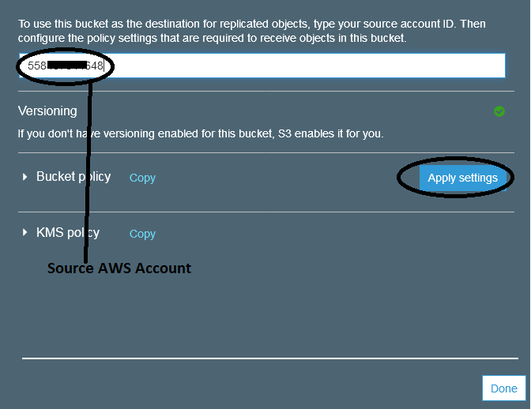

Click on **“Apply Settings”**

Then Click on **“DONE”**

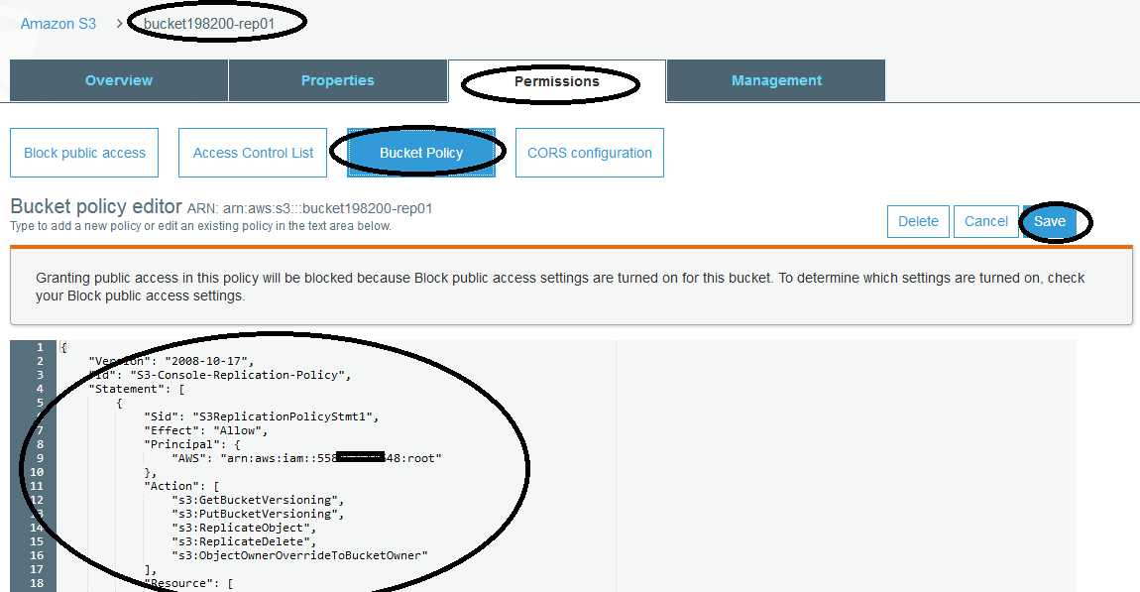

The Bucket policy should be listed as above.

Click on **“SAVE”**

1. Upload the file in the Source Bucket

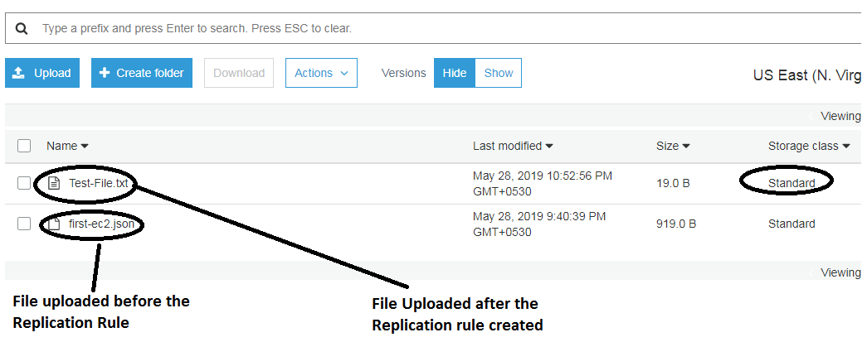

Files uploaded in the source Bucket

1. Observe the output

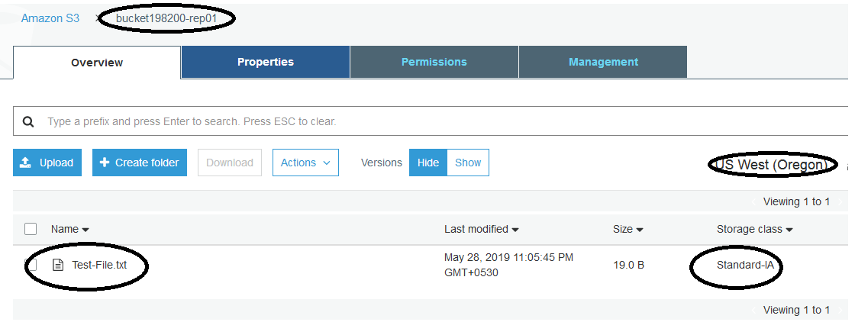

The file is replicated to the destination Bucket, with “**Standard-IA”**, as configured in the Replication Rule.

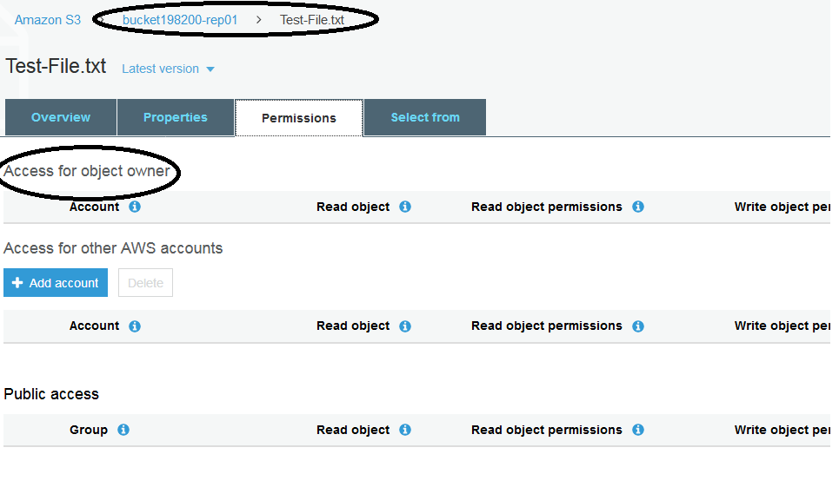

The owner does not have any permission to the file.

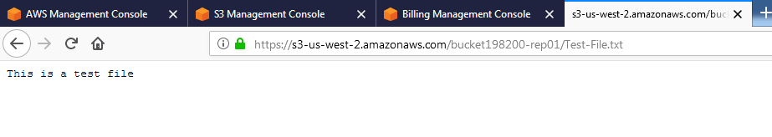

The file is visible via the link from the Destination Bucket as the file is made “**Public”** on the Source Bucket.